6th Grade – Unit Study Guide
Ratio Tables and Proportions

• Make a table of equivalent ratios to represent a proportional relationship between two quantities, when given a ratio.
1. Create a ratio table with the ratio 2:3.  2 3  4  6  8  10 | 2. Create a ratio table with the ratio $1.00:$2.50  $1.00 $2.50  $5.00  $10.00  $15.00  $20.00
3. Create a ratio table with the ratio 4.5 to 16.25  4.5 16.25 | 4. Create a ratio table with the ratio 5:9  5  50  100  200  500

• Make a table of equivalent ratios to represent a proportional relationship between two quantities, when given a practical situation.
5. Maggie is mixing red and blue paint. For every 5 cups of red paint, she uses 4 cups of blue paint. Create a table of values to represent this proportional relationship.  Amount of red paint Amount of blue paint | 6. Jim earns money during the summer by mowing lawns. For each lawn he mows, he earns $9.00. Complete the table to help Jim determine how much money he could make during the summer:  Number of Lawns Mowed Total Money Earned  1 Lawn  5 Lawns  10 Lawns  20 Lawns  40 Lawns  Earn at least $1,000
7. Marly earns $14 for completing 2 chores. Complete the table:  Chore Money Earned  1  2  3  4 | 8. Bill earns $0.20 for every can he collects. Complete the table:  Cans Collected Total Money Earned  5  20  50  65

• Identify the unit rate of a proportional relationship represented by a table of values or a verbal description, including those represented in a practical situation. Unit rates are limited to positive values.
9. Rachel types 162 words in 3 minutes. Rachel types at a constant rate.  How many words does Rachel type per minute? | 10. A car traveling at a constant speed traveled 260 miles in 4 hours. What was the cars speed?  A 65 hours per mile  B 65 miles per hour  C 1,040 hours per mile  D 1,040 miles per hour
11. Ralph drinks a bottle of green tea everyday at lunch. He is trying to find the best value for his green tea purchase. Complete the chart with the correct unit rates and determine which purchase the best value.  Price Unit Rate  2 pack of green tea for $2.34 $1.17 : 1 bottle  12 pack of green tea for $13.80  Case of 20 green teas for $25  Which purchase is the best value? Answer: | 12. The table shows the packs of gum that Lilly bought and the price she paid.  Packs of Gum Price  5 $0.50  10 $1.00  30 $3.00  60 $6.00  75 $7.50  Which statement is true?  A For every dollar paid, Lilly bought one pack of gum  B For every $0.10 paid, Lilly bought 5 packs of gum  C Lilly paid $0.50 per pack of gum  D Lilly paid $0.10 per pack of gum
13. Circle the two following that have the same price per ticket:

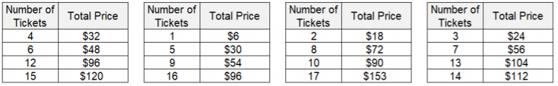

• Determine a missing value in a ratio table that represents a proportional relationship between two quantities using a unit rate. Unit rates are limited to positive values.
14. Fill in the missing values in the ratio table to find the unit rate.  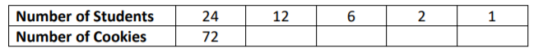 | 15.  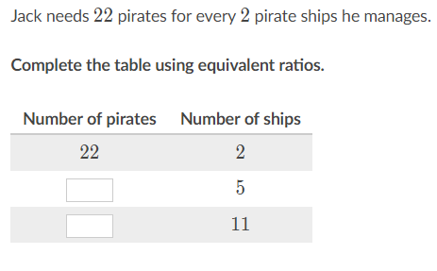
16. Allie is making cookies for her friends and she has 13 cups of chocolate chips. The recipe says that 2 cups of chocolate chips makes 12 cookies, so she makes this table to figure out how many people she can make cookies for. Help Allie complete the able by writing the correct values in the table:  Chocolate Chip Cookies  Number of Cups Number of People  2 12  4  5  48  13 | 17. A recipe requires that the amount of flour and sugar be added in a fixed ratio. The table below shows the amount of sugar needed with a given amount of flour:  Amount of Flour (cups) Amount of Sugar (cups)  4 5  8 10  12  16 20  20

• Determine whether a proportional relationship exists between two quantities, when given a table of values or a verbal description, including those represented in a practical situation. Unit rates are limited to positive values.
18. Proportional or not?  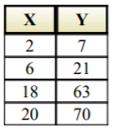 Explain how you know: | 19. Proportional or not?  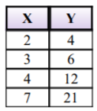 Explain how you know:
20. Is the following situation a proportional relationship or not?  Melanie rents a bike for $5.50 per day.  Explain how you know: | 21. Is the following situation a proportional relationship or not?  Melanie rents a bike for $5.50 plus $4 per day.  Explain how you know:
22. Identify the tables that represent a proportional relationship between x and y.

• Determine whether a proportional relationship exists between two quantities given a graph of ordered pairs. Unit rates are limited to positive values. Make connections between and among multiple representations of the same proportional relationship using verbal descriptions, ratio tables, and graphs. Unit rates are limited to positive values.
23. Given the graph,  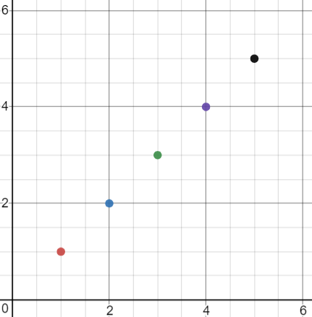  determine whether a proportional relationship exists and then explain why: | 24. Given the graph,  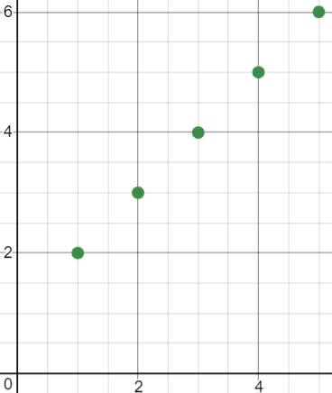  determine whether a proportional relationship exists and then explain why:
25. Carlos pays $15 for 5 hamburgers. If all the hamburgers at the restaurant cost the same amount, which would represent this situation?  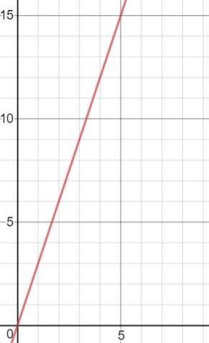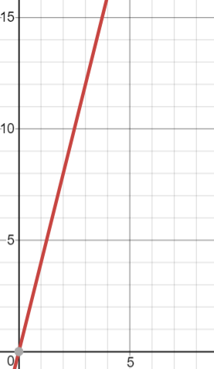 | 26. The graph shows the relationship between the amount of milk, m, and the amount of sugar, s, needed to be added to a recipe.  m  s  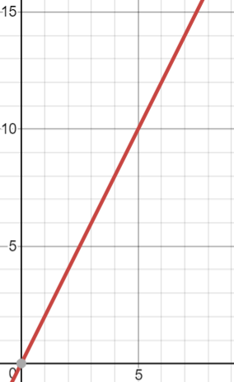  Which statement is true?  A The recipe calls for 2 cups of milk for every cup of sugar  B The recipe calls for 1 cup of milk for every 2 cups of sugar  C The recipe calls for ½ cup of milk for every cup of sugar

