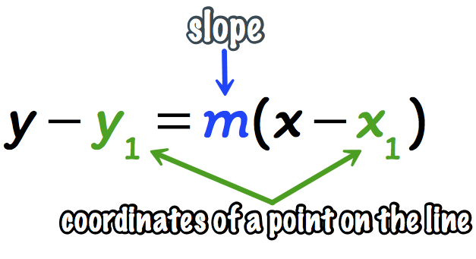
Name:_____________________________
Point-Slope Form Practice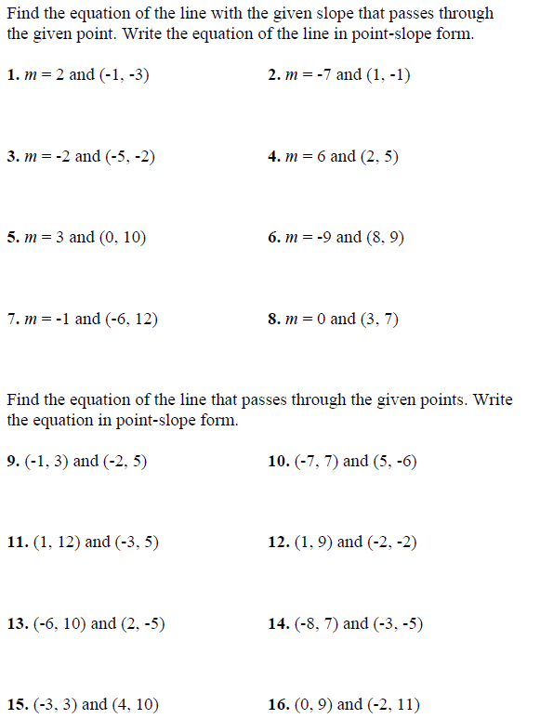
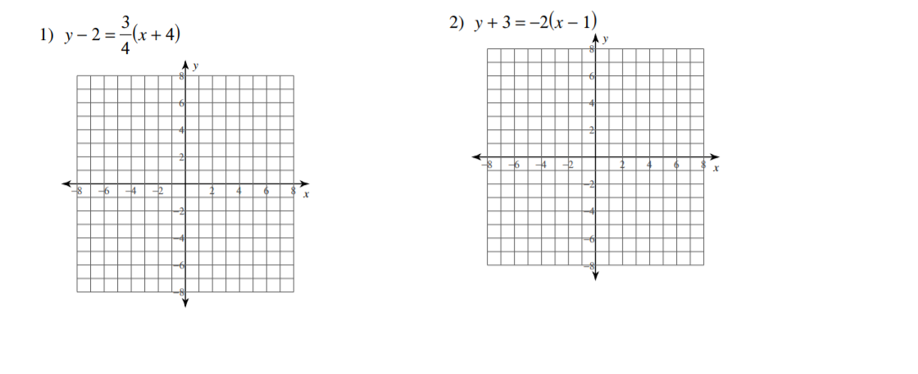
Each equation is given in point-slope form. Sketch the graph of each.
Remember, you must find the slope and the point from the equation first.

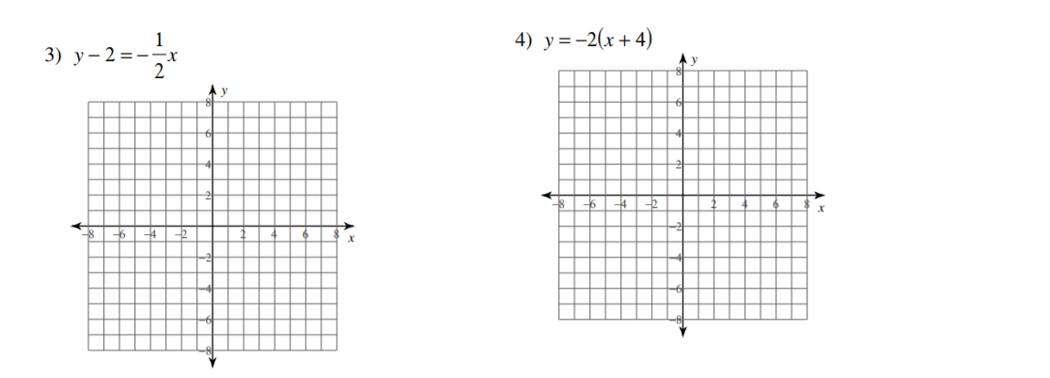

Write an equation for the following graphs written in point-slope form, using the point marked with a dot.
