Linear Regression Assignment Name:____________________________
Using Desmos software, enter data, create a regression line (line of best fit) and make predictions.
1) The following data follows a linear pattern. Find the line of best fit and then find the missing values.

x | y
13 | 29
15 | 33
20 | 43
44 | 91
47 | 97

a. What would be the equation for the line of best fit? __________________________________

b. If the chart continued as the following, what would be the missing value?

x | y
50 | ?
? | 113

2) The following data follows a linear pattern. Find the line of best fit and then find the missing values.

x | -10 | 4 | 16 | 24 | 32
y | -4 | -11 | -17 | -21 | -25

a. What would be the equation for the line of best fit? __________________________________

b. If the chart continued as the following, what would be the missing value?

x | 44 | ?
y | ? | -39

3) Every year since 1998, cases of the chicken pox have decreased. The chart below shows this:
a. What would be the equation for the line of best fit?

b. How many cases of chicken pox would there have been in 1990?

c. In what year should there have no longer been any cases of chicken pox?
Year | Cases of Chicken Pox (millions)
1998 | 10
1999 | 9
2000 | 7.2
2001 | 6.5
2002 | 5.8
2003 | 5
2004 | 4

4) Sheetz convenience stores notice that the hotter the day, the more drinks their store sells. In order to stay stocked appropriately, the manager assembles the data to send to their drink suppliers.
a. What would be the equation for the line of best fit?

b. Use the line of best fit equation to predict the drink sales if the temperature is 95°F?

c. If the manager checks his sales at the end of the day and he has sold 95 drinks during the day, what is likely the temperature outside?
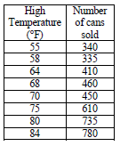

5) Since 1938, the United States has increased the minimum wage. The chart below shows this:
Year | Minimum Wage
1938 | $0.25
1939 | $0.30
1945 | $0.40
1950 | $0.75
1961 | $1.15
1963 | $1.25
1967 | $1.40
1968 | $1.60
1974 | $2.00
1975 | $2.10
1976 | $2.30
1978 | $2.65
1979 | $2.90
1980 | $3.10
1981 | $3.35
1990 | $3.80
1991 | $4.25
1996 | $4.75
1997 | $5.15
2007 | $5.85
2008 | $6.55
2009 | $7.25

a. What would be the equation for the line of best fit?

b. In what year would the minimum wage likely have been $1.00?

c. What do you predict the minimum wage to be in 2020?

6) Answer the following questions about the line of best fit:
a. Select two of the following that describe the line of best fit:
Positive Correlation | Negative Correlation
Indirect Variation | Direct Variation

b. What would be the equation of the line of best fit?

c. If you sold 100 tickets, how much money would you make?

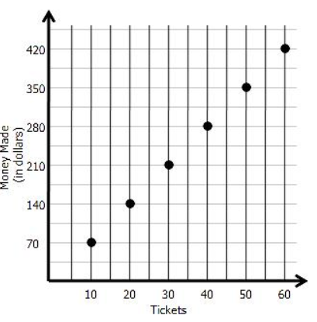

6) The scatterplot below shows the relationship between the number of bags of popcorn that are sold and the price per bag. Which of the lines of best fit look most accurate. Choose one: