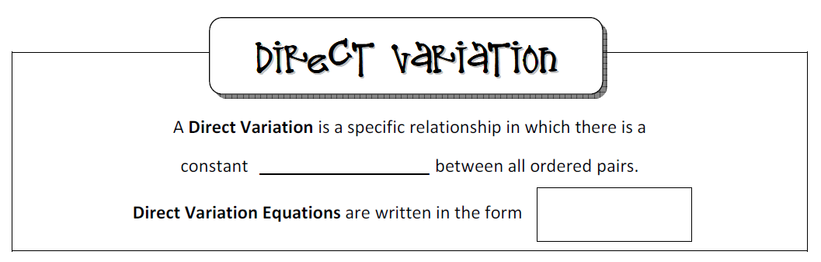

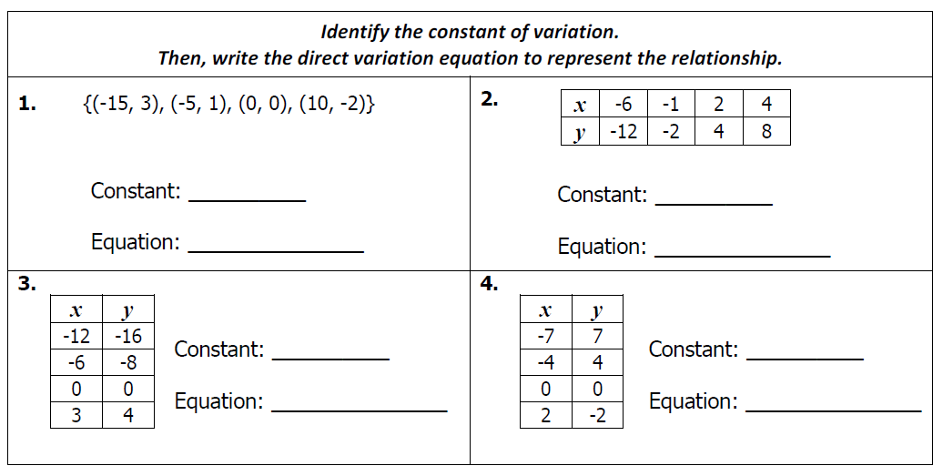

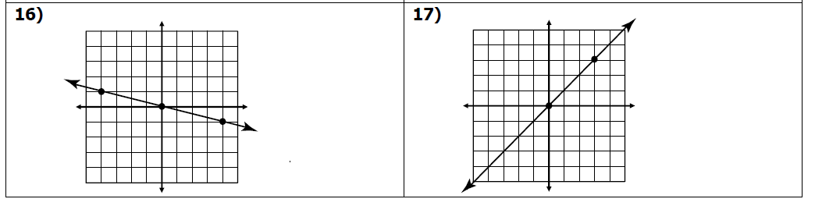

**6.C**

**5.C**



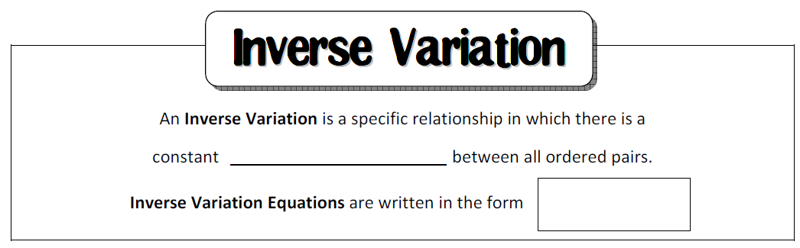

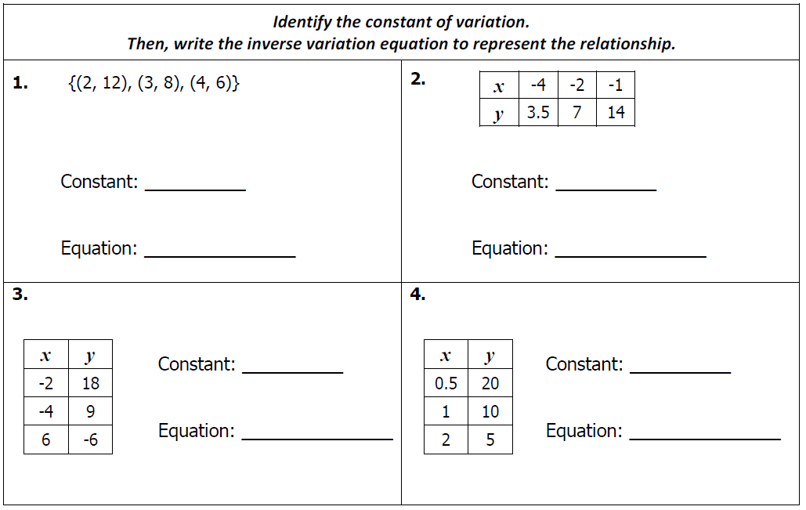

**11.**

**10.**

**8.C**

**7.C**

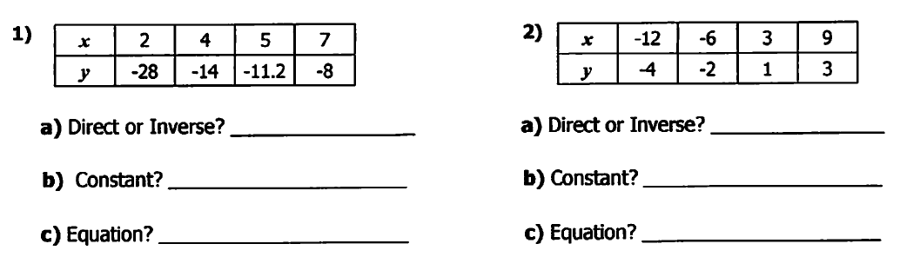

**13.**

**12.**

**14. 15.**

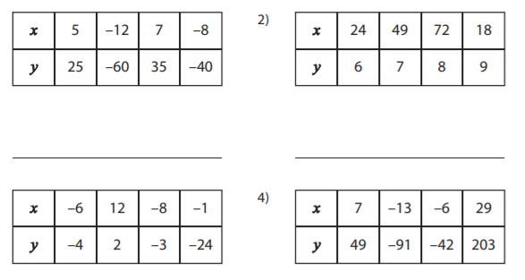 

**a) Direct, Inverse, or Neither? ____________ a) Direct, Inverse, or Neither? ____________**

**b) If direct or inverse, what is the equation? b) If direct or inverse, what is the equation?**

**16. 17.**

 

**a) Direct, Inverse, or Neither? ____________ a) Direct, Inverse, or Neither? ____________**

**b) If direct or inverse, what is the equation? b) If direct or inverse, what is the equation?**

15. Place a CIRCLE around each table that represents DIRECT variation.

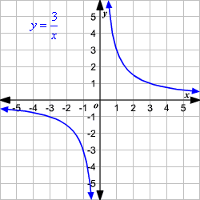 Place a STAR around each table that represents INVERSE variation.

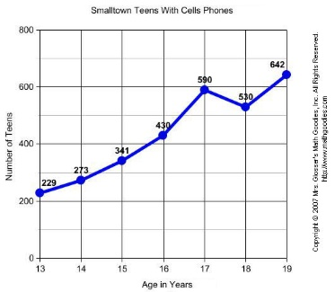 Leave any answer BLANK that is NEITHER.

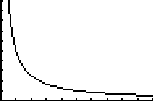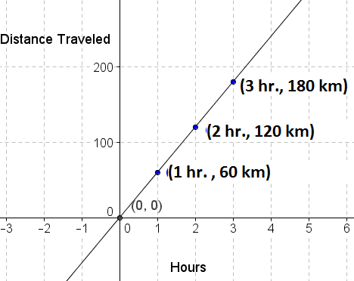

18. Place a CIRCLE around each equation that represents DIRECT variation.

Place a STAR around each equation that represents INVERSE variation.

Leave any answer BLANK that is NEITHER.

|  |  |  |  |
| --- | --- | --- | --- |
| $$y=\frac{6}{x}$$ | $$y=3x^{2}$$ | $$y=-25x$$ | $$y=\frac{1}{x}$$ |
| $$y=3x$$ | $$y=7x+1$$ | $$y=\frac{0.5}{x}$$ | $$y=-0.7x$$ |
| $$y=2x-3$$ | $$y=\frac{-18}{x}$$ | $$y=\frac{1}{x^{3}}$$ | $$y=-9x^{2}$$ |