Graph Sketch (Parabola) | Concavity | y-intercept | x-intercept(s) | Zeros | Roots | Circle # of solutions | Vertex | Axis of Symmetry
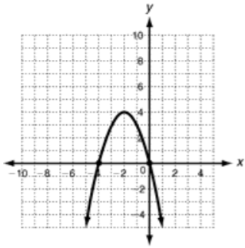 | Concave Up  Concave Down |  |  |  |  | Zero  One  Two
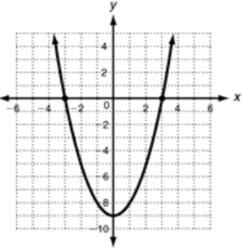 | Concave Up  Concave Down |  |  |  |  | Zero  One  Two
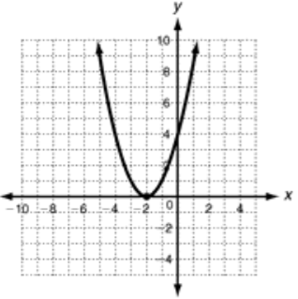 | Concave Up  Concave Down |  |  |  |  | Zero  One  Two
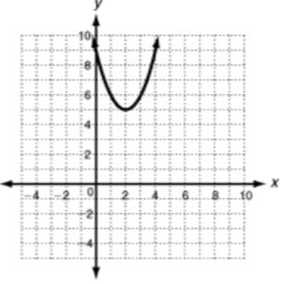 | Concave Up  Concave Down |  |  |  |  | Zero  One  Two
Name:________________________________________ Characteristics of Quadratic Functions (A.7)

Factor the quadratic, graph in Desmos and sketch, and then name it’s zeros and roots.
What do you notice about the connection between the zeros, roots, and factors?
Function | Factored Form | Graph | x-intercept(s) | Zeros | Roots | Connection between Factors and Intercepts (Roots/Zeros)
f(x) = x² – 2x – 8 | *use the add and multiply method | 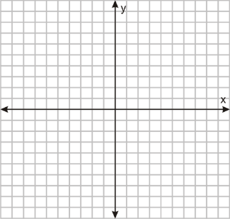
f(x) = x² + 4x + 4 | *use the add and multiply method
y = x² – 9 | *use the difference of squares method

Use the connections you found above to make an educated guess about the following problems:
1. A graph has x-intercepts at (-10,0) and (12,0). It’s factors are ( + ) ( – )
2. A graph has zeros at x = 14 and x = -20. It’s factors are ( – ) ( + )
3. A graph has roots of 11 and 12. It’s factors are ( – ) ( – )
4. A graph has roots of -9 and -15. It’s factors are ( + ) ( + )

