**Algebra Review #42 *SHOW HOW YOU SOLVED EACH PROBLEM***

1.

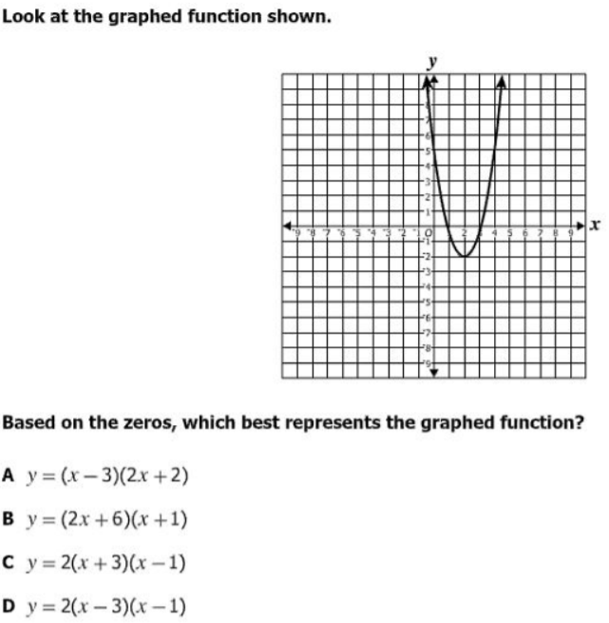

2. A data set with an even number of data points is ordered from least to greatest. The middle two data points are represented by x1 and x2. This formula can be used to find the median of the data set. 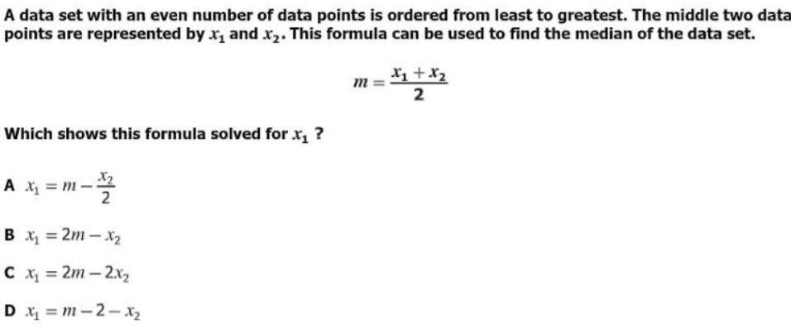

3.

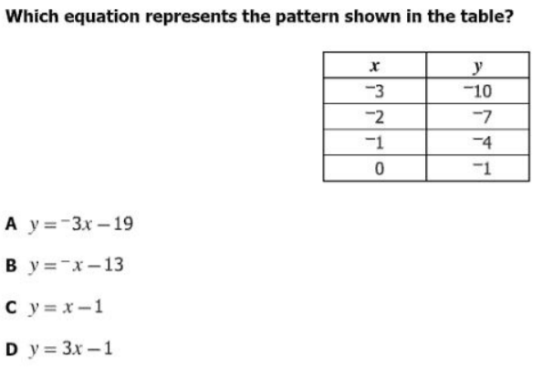

**NAME ___________________________**

4.

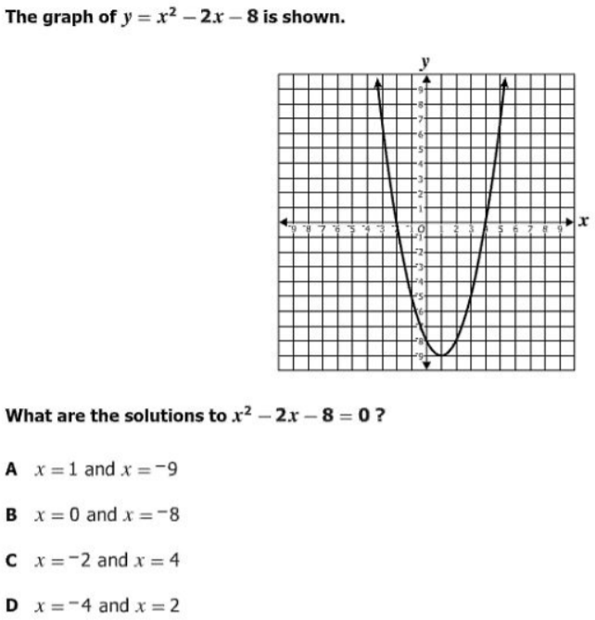

5.

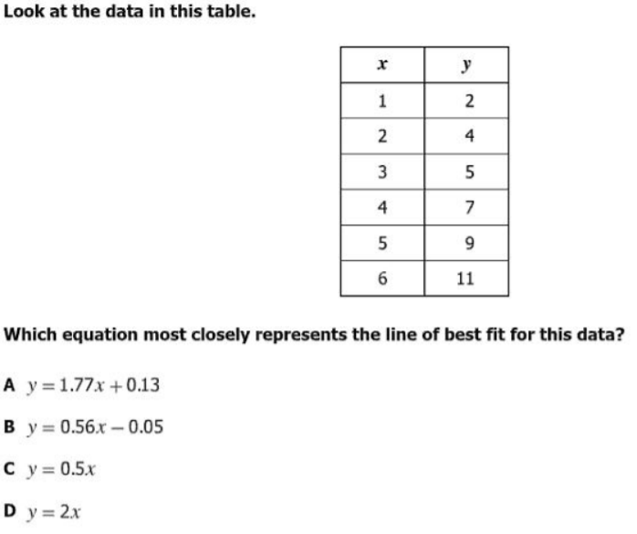

6.

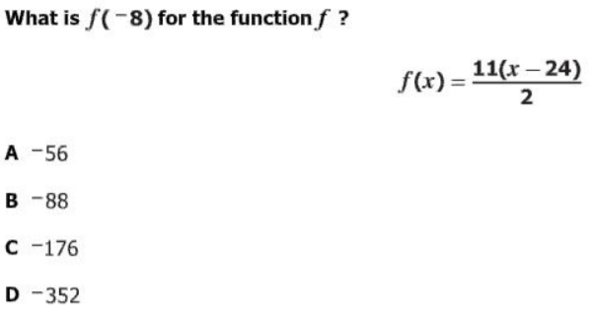

7.

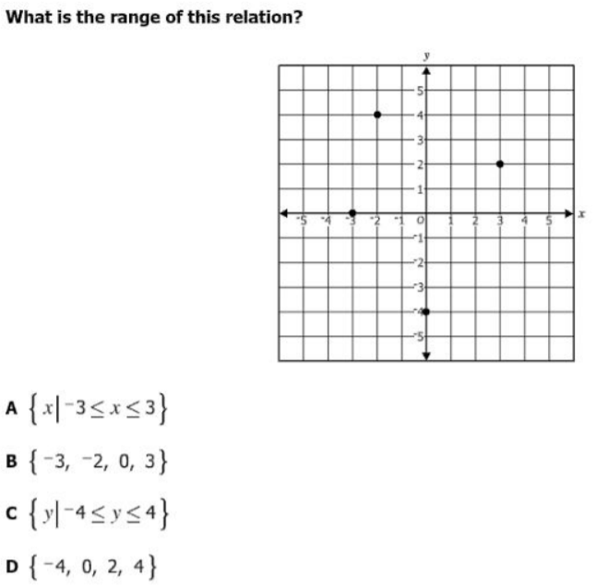

8.

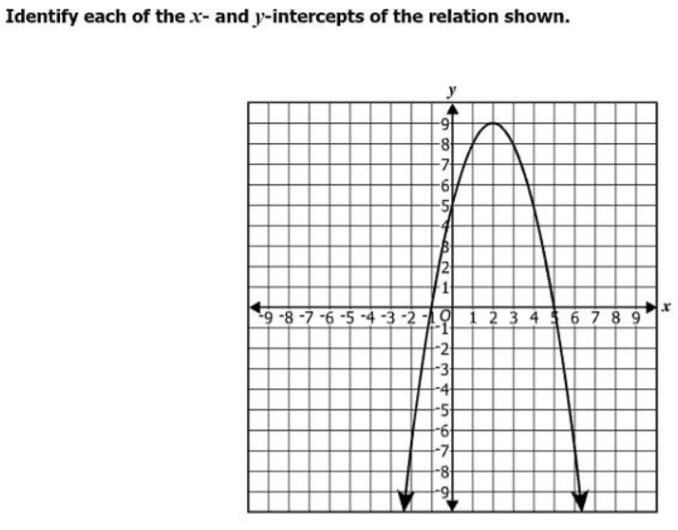

9. 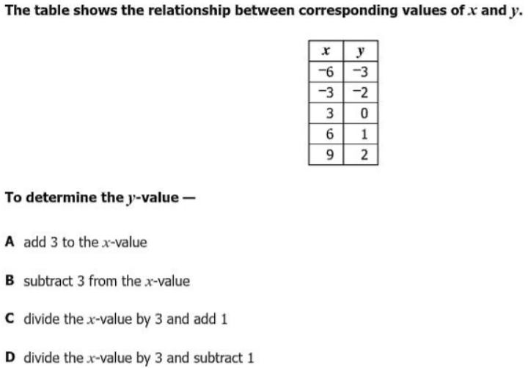

10. Which graph appears to show a relation that is NOT a function?

