Grade 7 Mathematics
2018-2019 Mathematics Standards of Learning
TEST ITEM SET

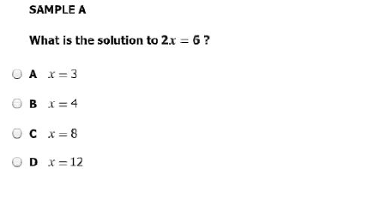

--------------------------------------------------------------------------------------------------------------------------------

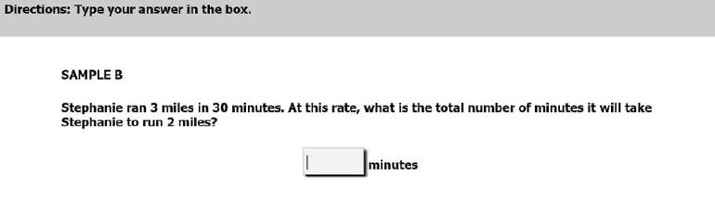

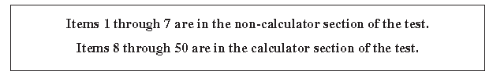
1.
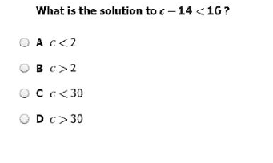
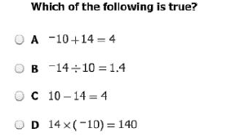
-----------------------------------------------------------------------------------------------------------------------
2.
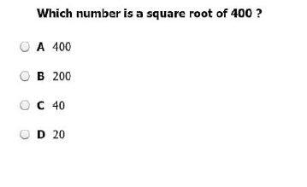
3.

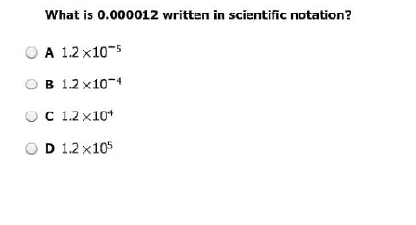
----------------------------------------------------------------------------------------------------------------------------------
4.
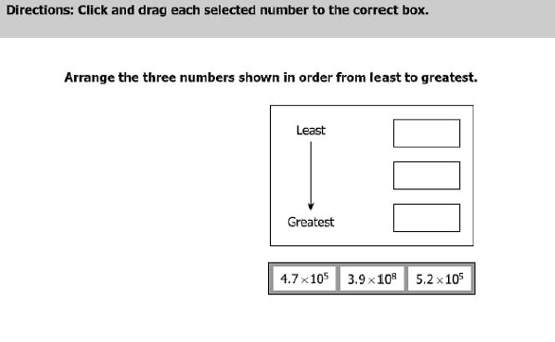
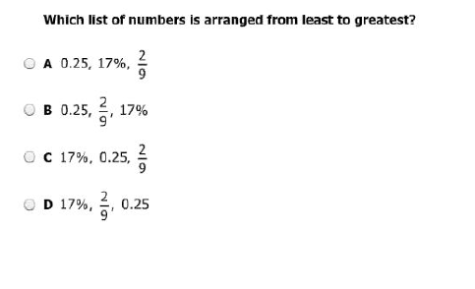
5.
----------------------------------------------------------------------------------------------------------------------------------
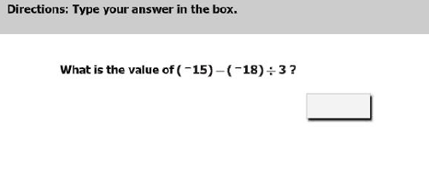
6.
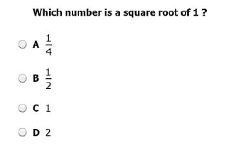
7.
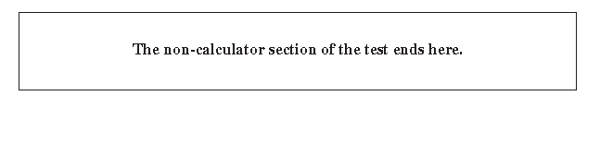

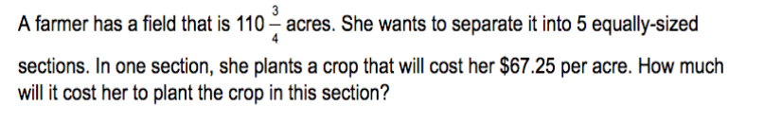
8.

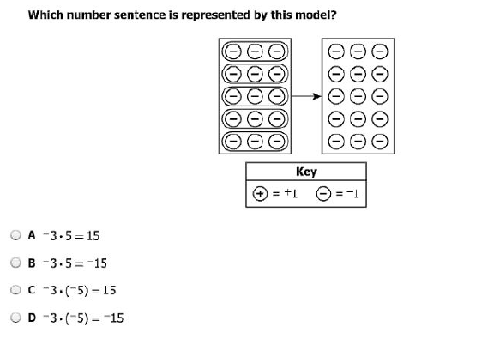
9.
--------------------------------------------------------------------------------------------------------------------------------------
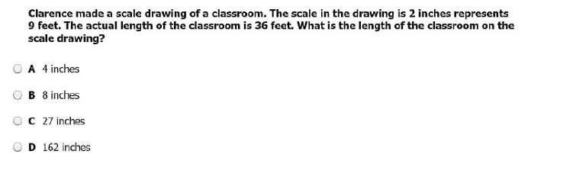
10.
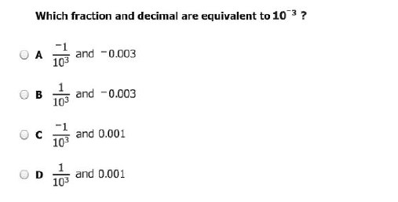
11.
----------------------------------------------------------------------------------------------------------------------------------------
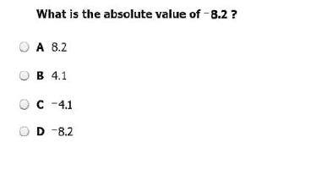
12.
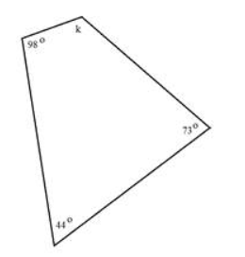
13.
Find the value of k.

K =?

------------------------------------------------------------------------------------------------------------------------------------------
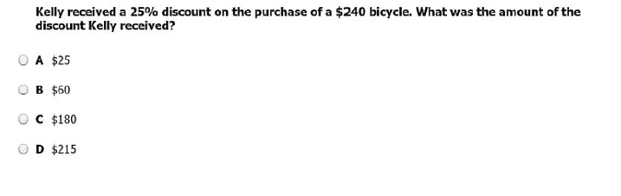
14.
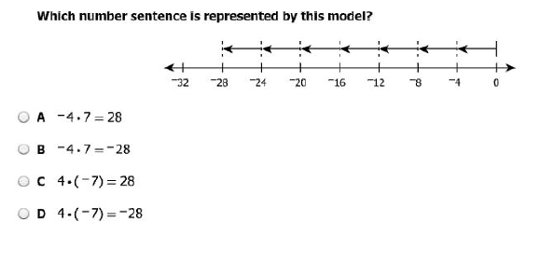
15.
----------------------------------------------------------------------------------------------------------------------------
16.

17.
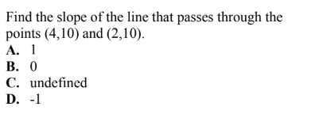
------------------------------------------------------------------------------------------------------------------------------------------
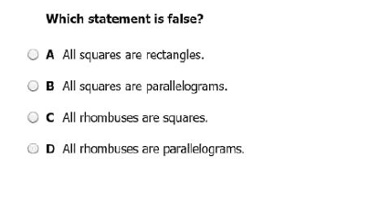
18.

If point U is translated left 5 units and down 2 units, what is the new location U’?
19.
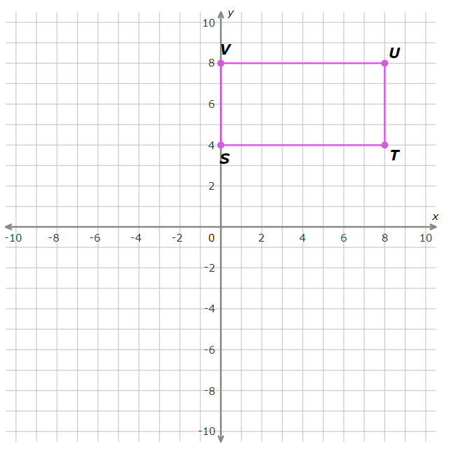
A (3, 6)
B (6, 3)
C (8, 8)
D (3, 10)
------------------------------------------------------------------------------------------------------------------------------------------
20.
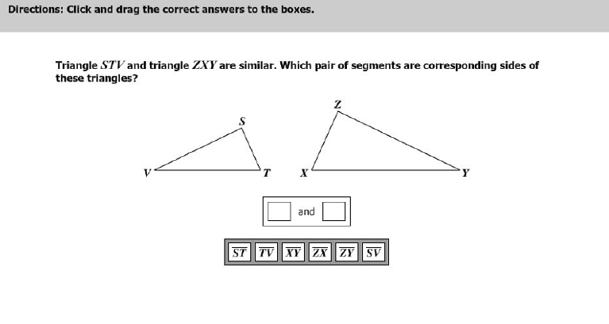
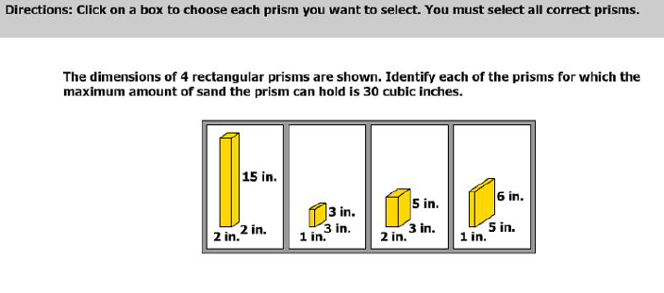
21.

22.
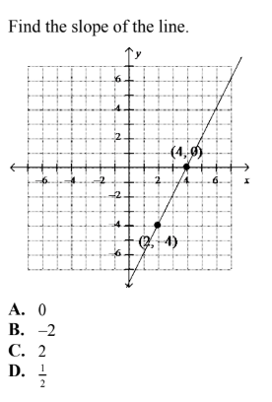

23.
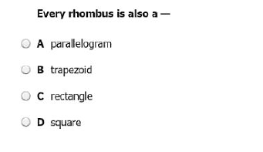
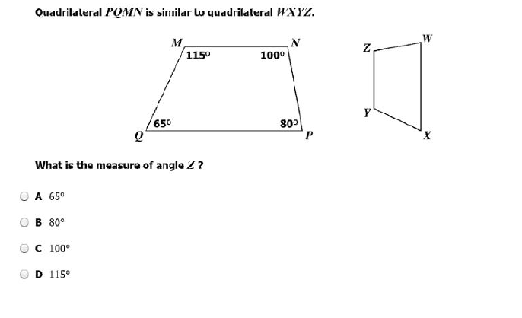
24.

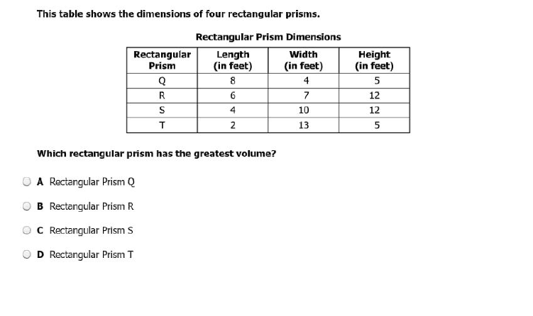
25.
------------------------------------------------------------------------------------------------------------------------------------------
Solve the following inequality?
26.
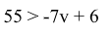
- v < -7
- v > -7
- v < 7
- v >7

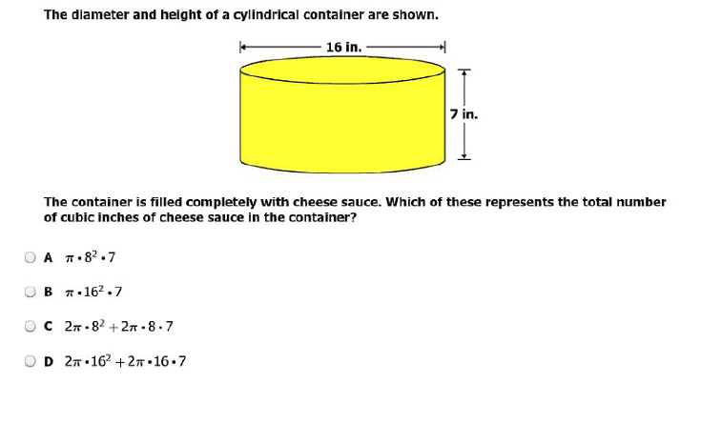
27.
------------------------------------------------------------------------------------------------------------------------------------------
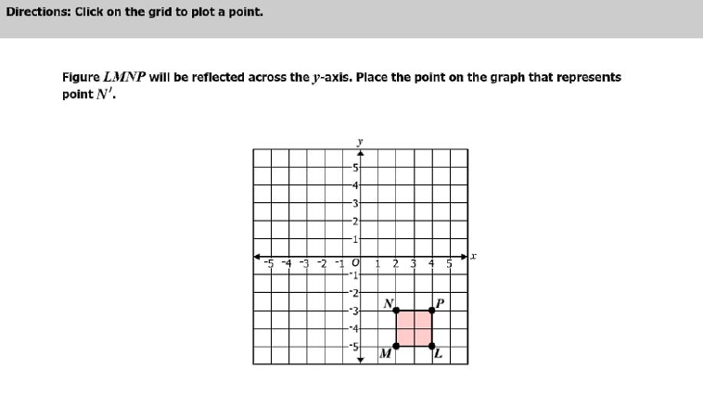
28.
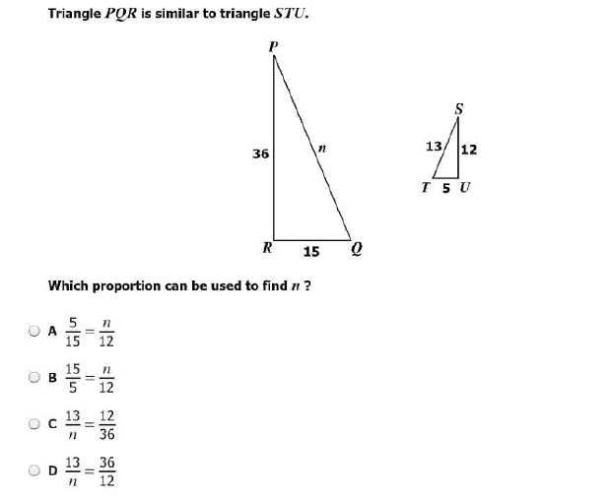
29.

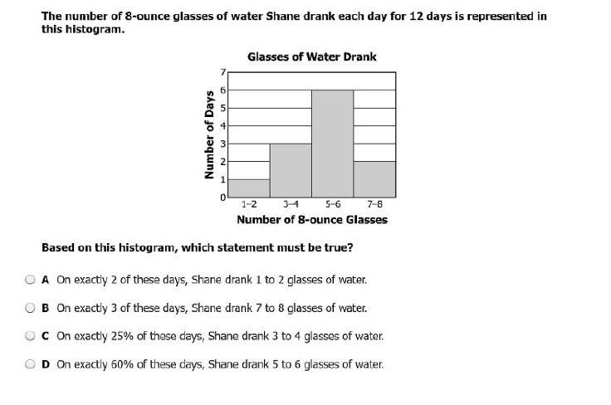
30.
---------------------------------------------------------------------------------------------------------------------------------
Find the y-intercept given the table.
31.
X | Y
-1 | 2
0 | 3
2 | 5
8 | 11

The y-intercept is: __________
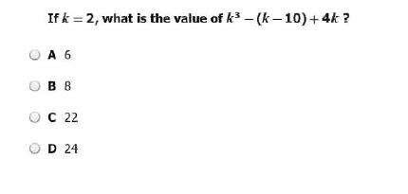
32.
-----------------------------------------------------------------------------------------------------------------------------------------
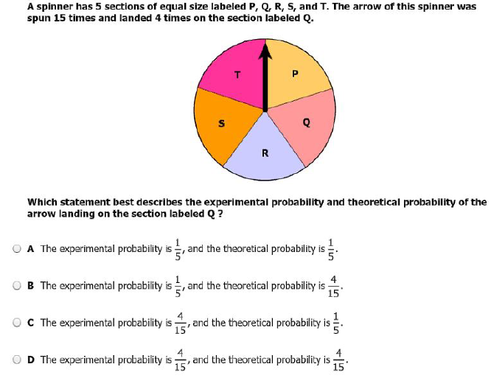
33.
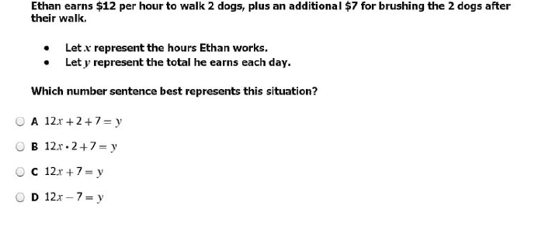
34.

------------------------------------------------------------------------------------------------------------------------------
35.

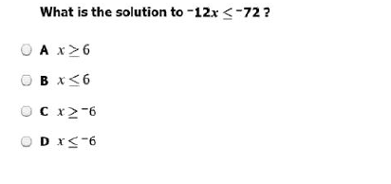
36.

-------------------------------------------------------------------------------------------------------------------------------
37.
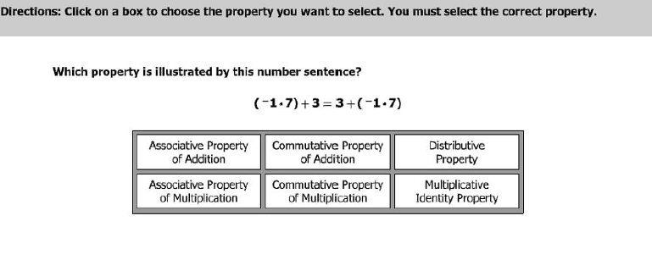

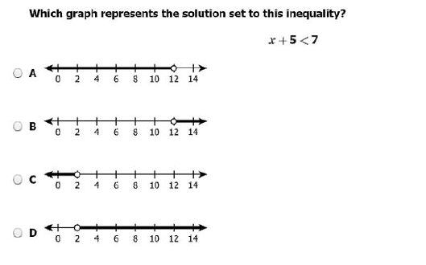
38.
----------------------------------------------------------------------------------------------------------------------------------------

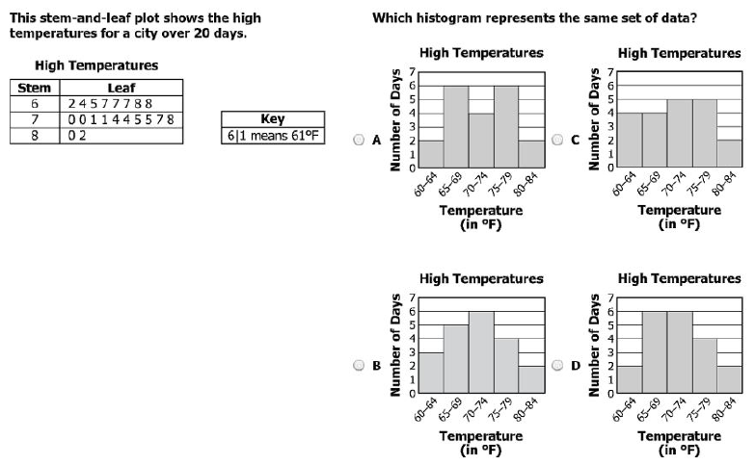
39.

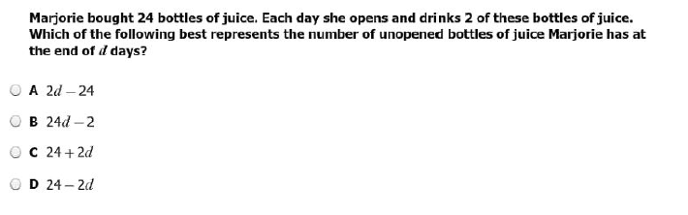
40.
------------------------------------------------------------------------------------------------------------------------------------------
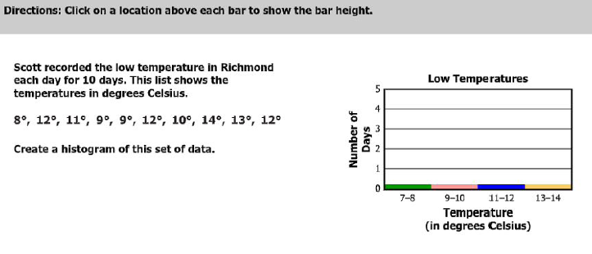
41.

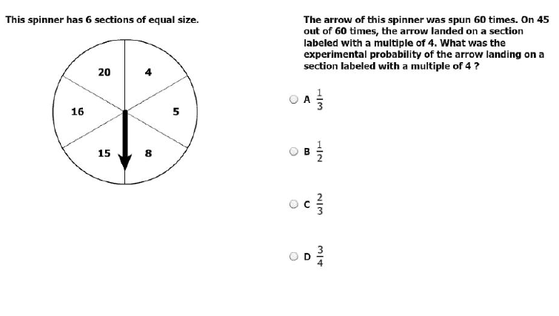
42.

-----------------------------------------------------------------------------------------------------------------------------------------
43.
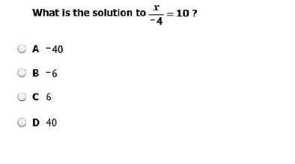

44.
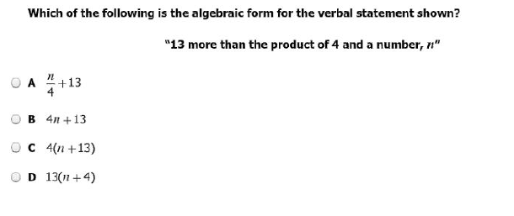----------------------------------------------------------------------------------------------------------------------------------

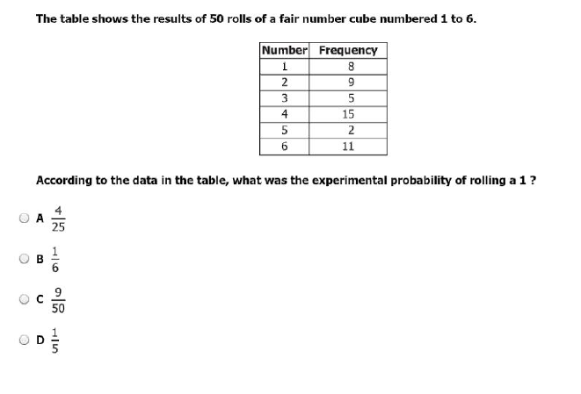
45.
46.
-------------------------------------------------------------------------------------------------------------------------
Solve
$5+\left(7-12\right)+ \sqrt{169}$

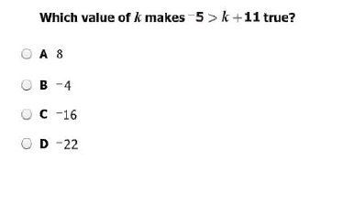
47.
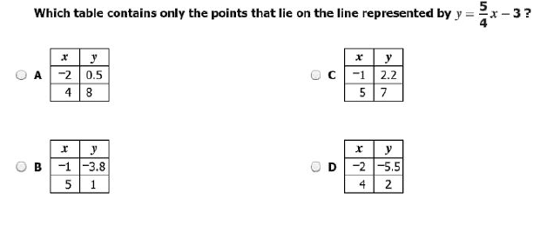
48.
----------------------------------------------------------------------------------------------------------------------------------
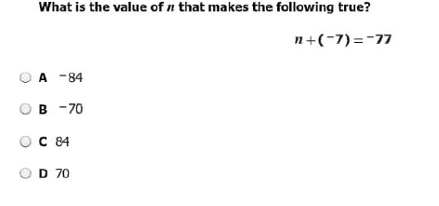
49.
---------------------------------------------------------------------------------------------------------------------------
50.

