6th Grade –Study Packet
6.6ab Integer Operations

Skill #1 – Add and Subtract Integers
1. What is the value of?  a) -7 + 17 =  b) -4 + 10 =  c) -18 + 14 =  d) 6 + -4 =  e) -45 + -27 = | 2. What is the value of?  a) -7 – 8 =  b) 14 – 24 =  c) -45 – (-15) =  d) -5 – 19 =  e) -8 – (-4) = |  | 2. What is the value of?  a) -13 + -9 =  b) 64 – (-4) =  c) -74 + 21 =  d) -73 – 10 =  e) 8 – 18 =
4.  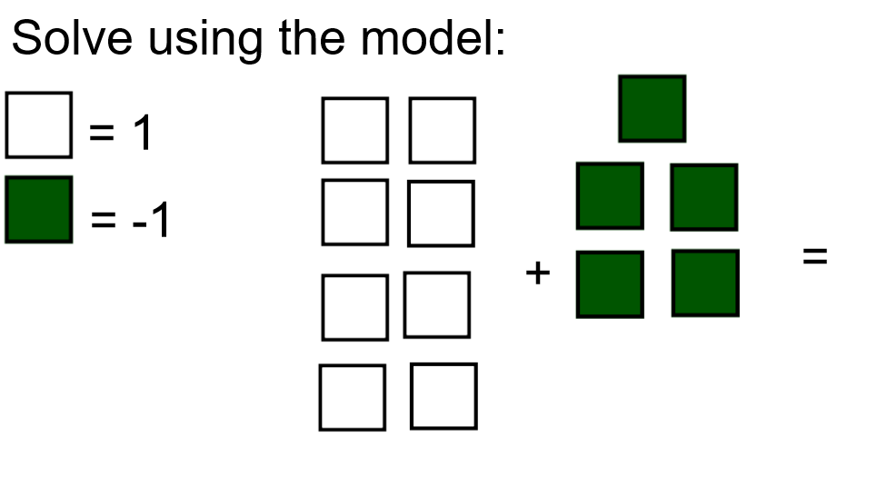 |  | 5.  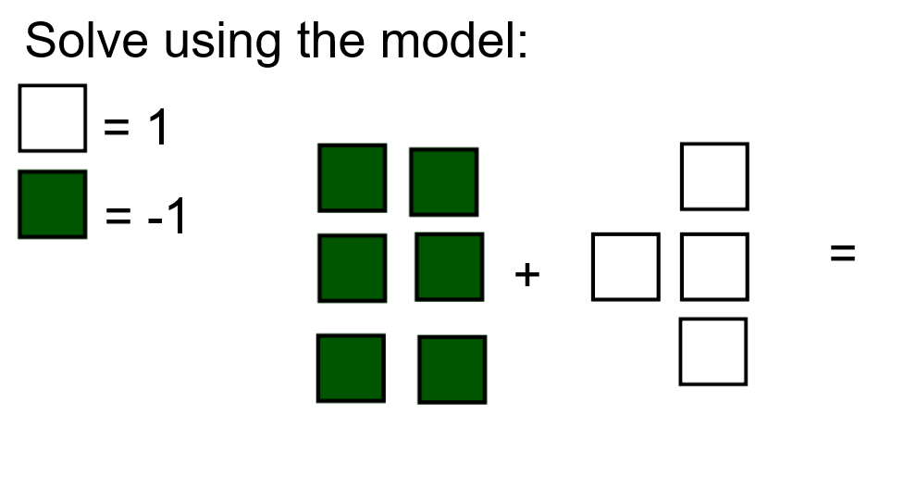
6.  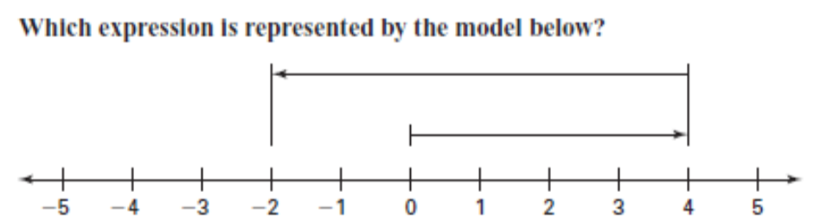 |  | 7.  What expression is represented by the model below?  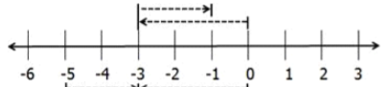
8. A fish dives 30 feet under the surface of the ocean. He changes his position by coming up 14 feet. What is the integer that now describes his position? |  | 8. The temperature outside is 17 degrees below zero. If the temperature rises 11 degrees, what integer represents the new temperature?
Skill #2 – Multiply and Divide
1. What is the value of?  a) -3 · -9 =  b) 4 · -5 =  c) (-12) · (-2) =  d) (-6) · 10 =  e) (4) · (-11) = | 2. What is the value of?  a) -100 ÷ 10 =  b) -27 ÷ -27 =  c) 24 ÷ -3 =  d) -55 ÷ 11 =  e) -32 ÷ -8 = |  | 3. What is the value of?  a) 8 · -3 =  b) 18 ÷ -6 =  c) -6 · -9 =  d) -25 ÷ -5 =  e) 3 · 7 =
5. Identify each true statement:

-4 · -5 = -20 | 1 – 7 = 6 | -2 + 13 = 11
-4 ÷ -2 = 2 | 2 · -5 = -10 | -14 + 10 = -4

6. Identify each false statement:

-3 · 12 = 36 | (-5) – (-7) = 2 | -5 + -16 = -21
-100 ÷ 50 = 2 | 2 · -7 = 14 | (-1) – 4 = -5

7. Eric’s bank account is currently at -$25.00. What amount of money would he need to earn to have a balance of $0.00? |  | 8. Write a subtraction number sentence to describe the situation below: 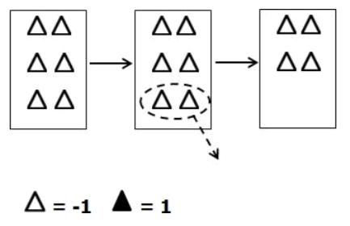
9. On a particular day in Bristol, the temperature is 14 degrees Farhenheit oustide. That night, it drops to -5 degrees Farhenheit. By how many degrees has the temperature dropped?

A 9 B 8
C 19 D 20

